Mapping feature and user stories

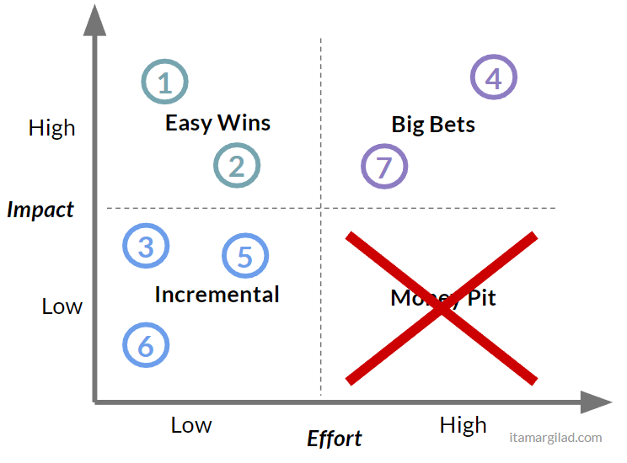

Identifying the urgent vs important

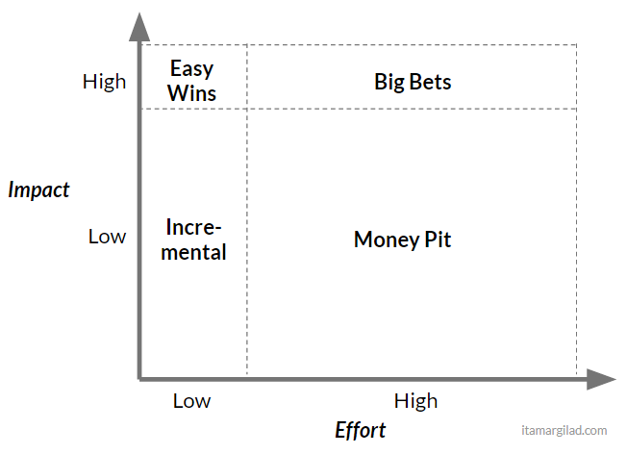

Discharge the no needed

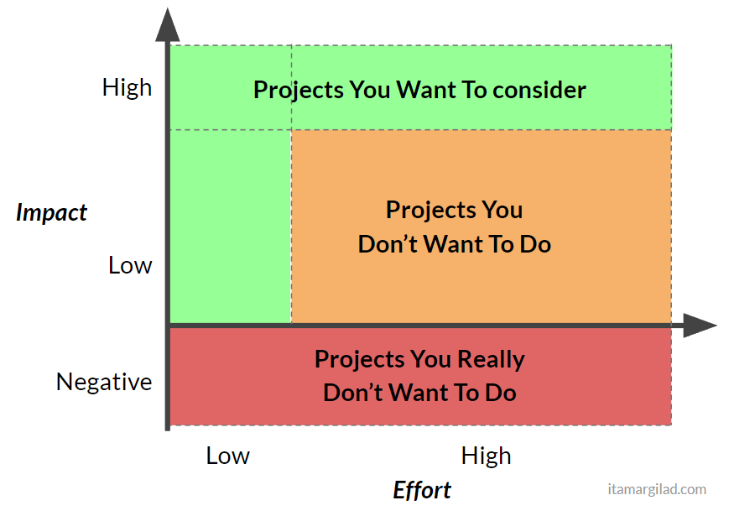

Understanding the impact

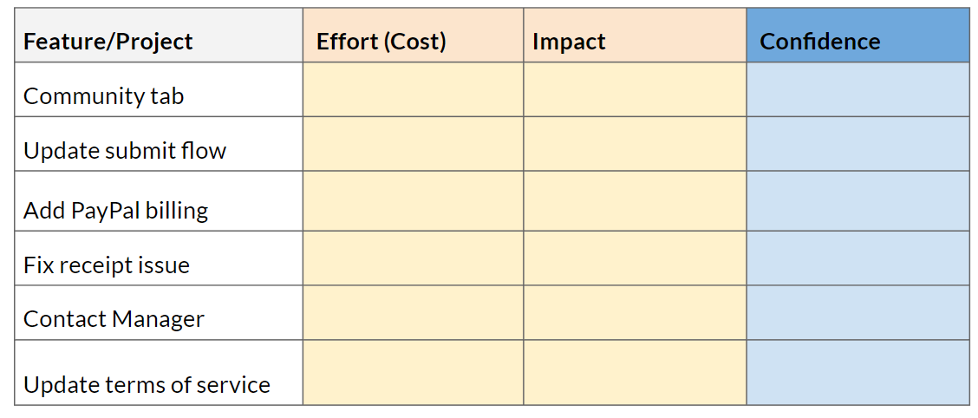

Grooming the backlog start with the **Backlogs views**

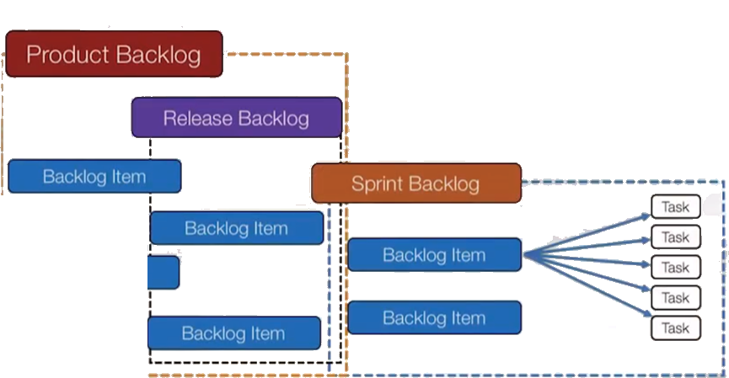

Analyse the **Scope**

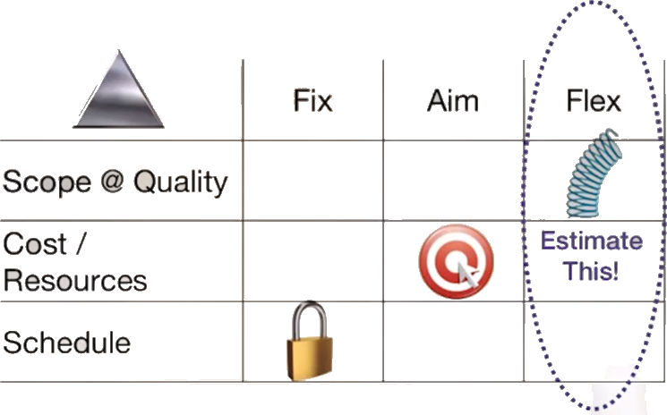

Add the team **Analytical prediction**. It is the agreement on predicted velocity to deliver the work and a calibration of the effort

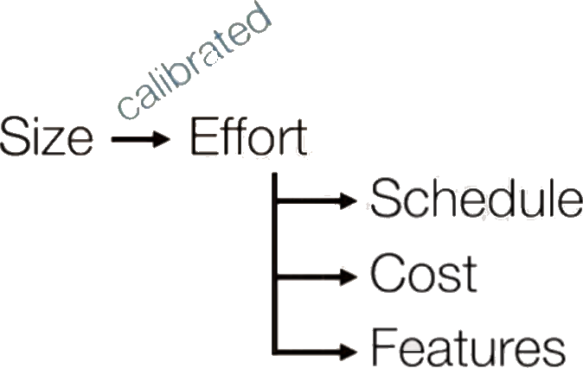

Putting all together with **Stories estimation**

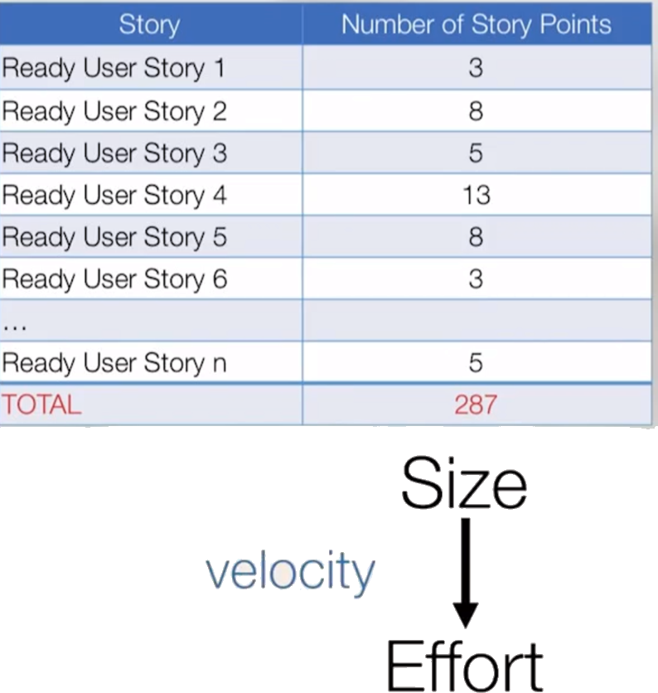

Add to **Sprint Planning**

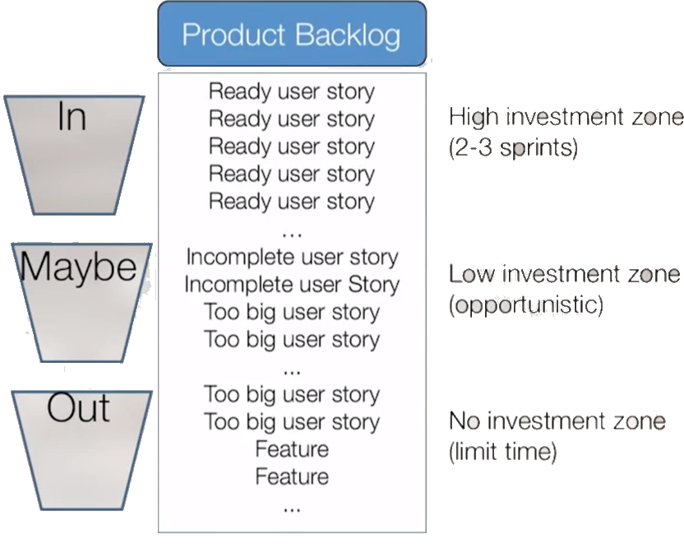

User stories- **Breaking by** **Workflow**

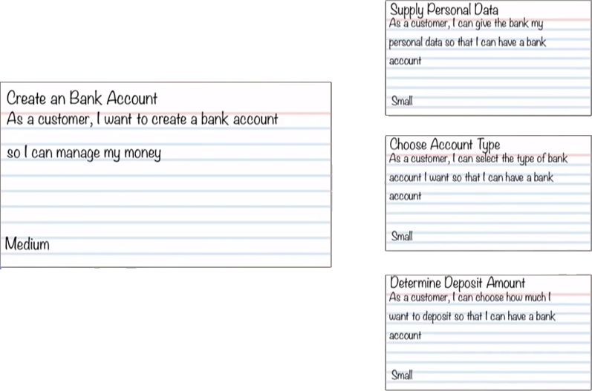

User stories- **Breaking by** **Type**

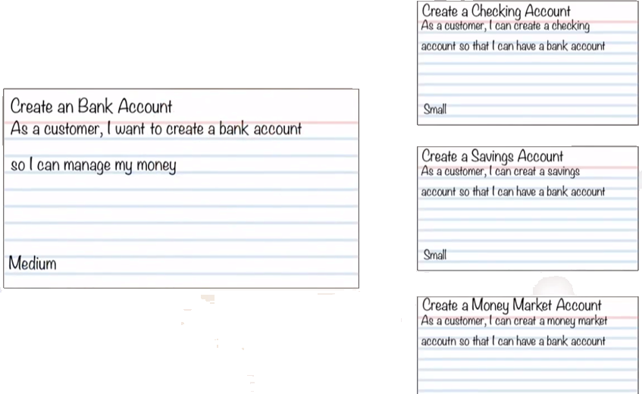

User stories- **Breaking by** **Data boundaries**

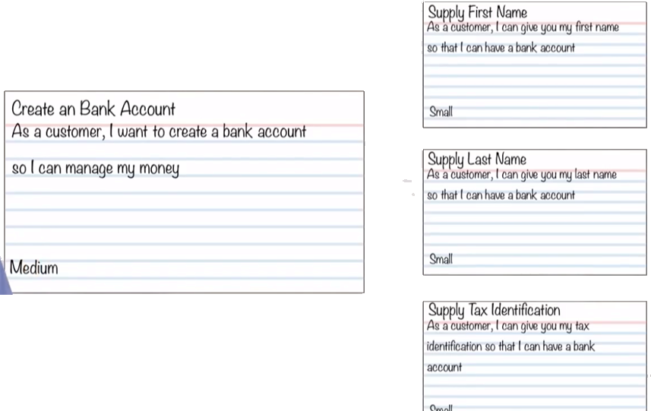

User stories- **Breaking by** **Create/ Read/ Update/ Delete**

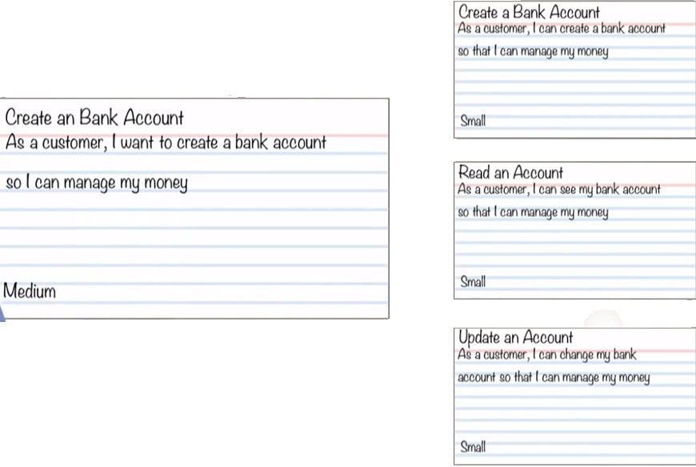

**What NOT to do By Architectural components**

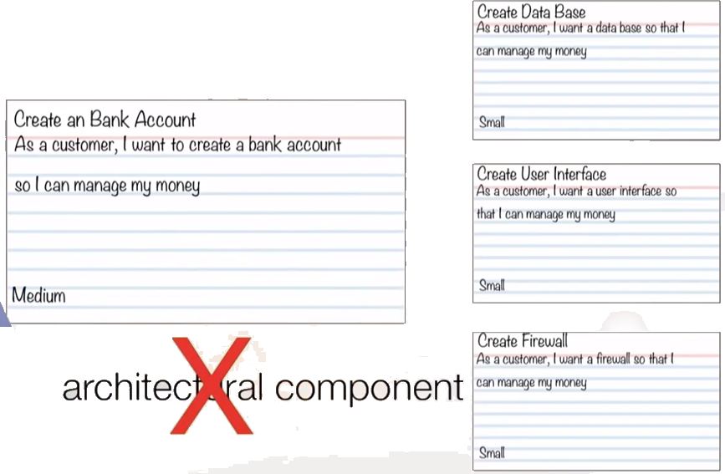

**What NOT to do By Function and non-function**

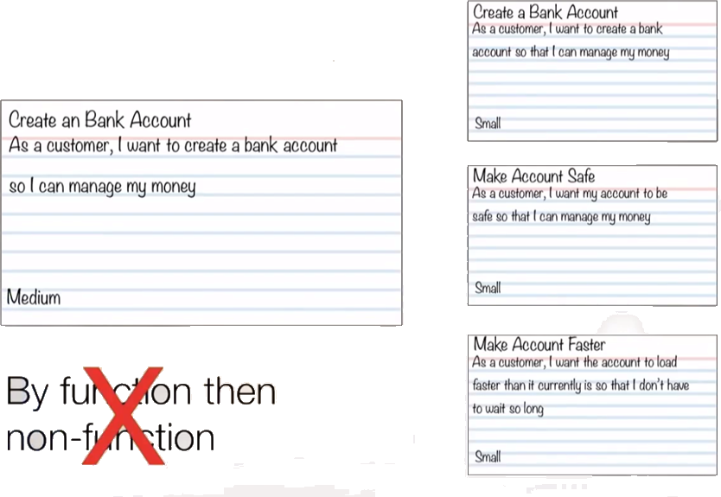

**Prioritization Schema**

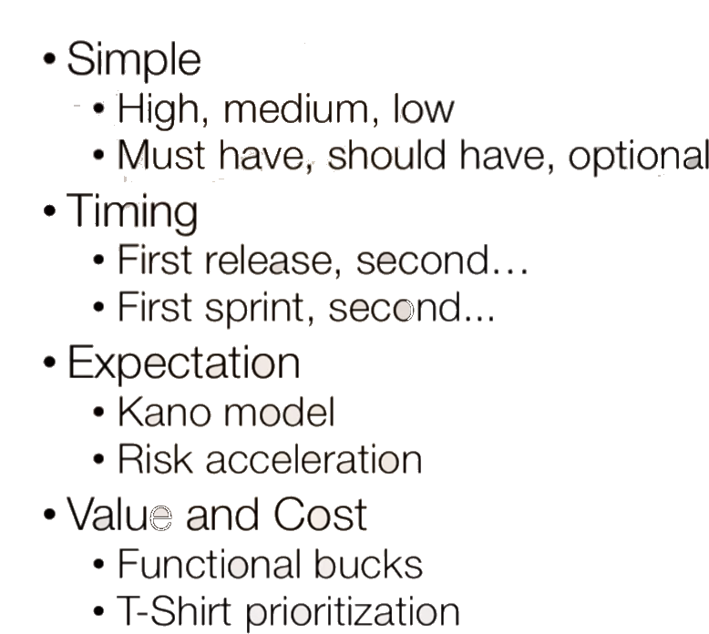

**User Story Map**

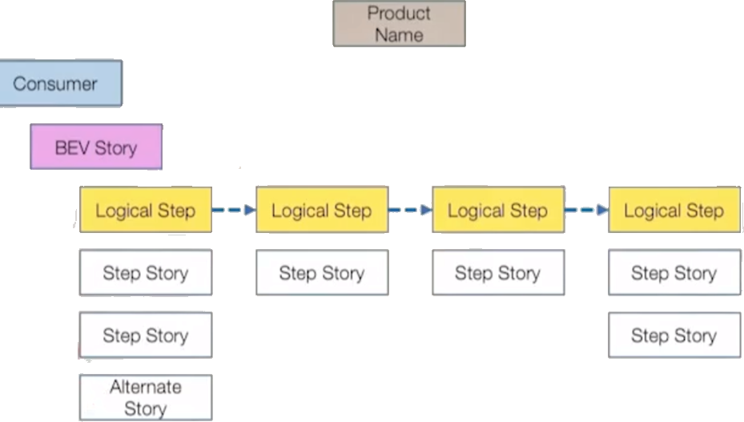

**How to use User Story Map – example**

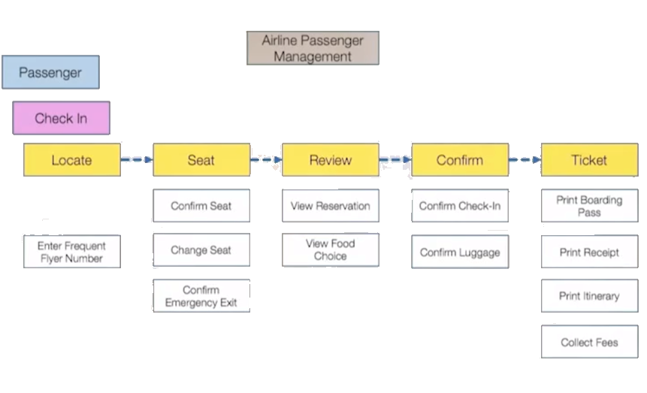

**Selecting the user story for a sprint- release- objective**

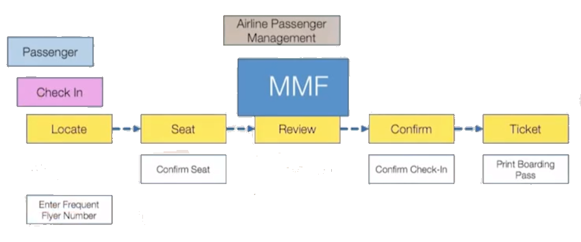

**Producing a Release plan**

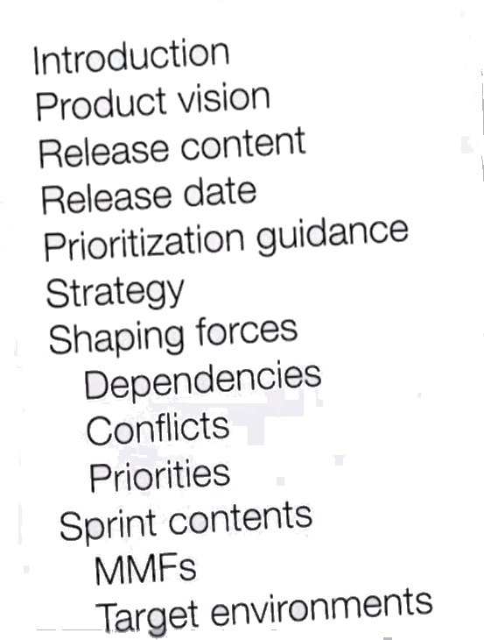

**Example of a Release Roadmap**

